ES35A: Behaviour Reflection Sheet

Junior Primary Students
Applicable to Community Language Schools SA and all member schools

Student’s Name: ……………………………………………………………………
Year Level: …………………………………. Class: …………………………….
Teacher: ……………………………………. Date: ………….../…………./ 20

You are here as a result of inappropriate behaviour. You are required to reflect on your behaviour and answer the questions on this sheet.
Please give some time and thought to your answers.

- What were you feeling? (Please circle)
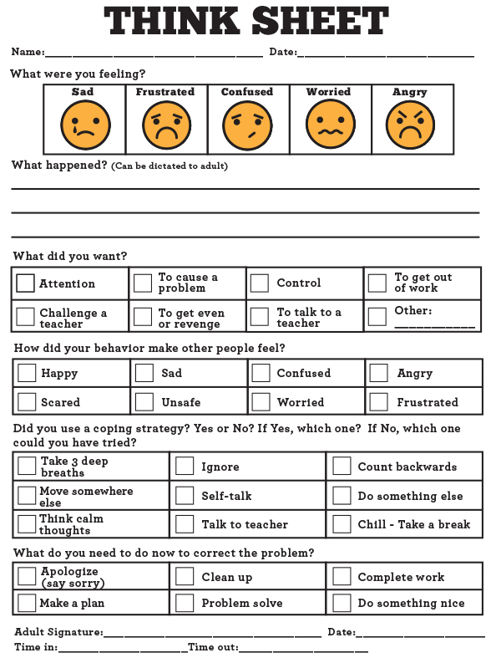
Other: ……………………

- What did you choose to do? (Please circle. Can be more than one)
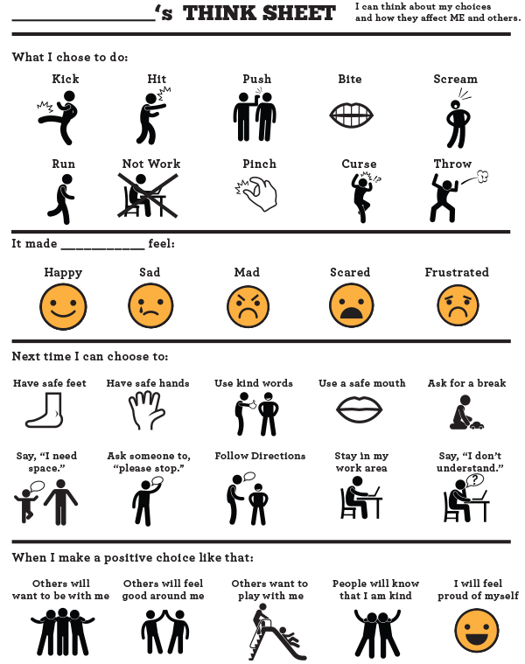
Other: ………………….

- What happened? (can be dictated to an adult)
……………………………………………………………………………………………………………………………………………………………………………………………………………………………………

- Why did you make this choice? (Please tick. Can be more than one)
To get attention
To cause a problem
To be in control
To get out of work
To challenge a teacher
To get even because I was being disturbed/bullied
To talk to a teacher
Other:
- Who is affected by your behaviour? (Please tick. Can be more than one)
Myself
My classmates
My school mates
My teacher
The other person

- How did your behaviour make others feel? (Please tick. Can be more than one)
Sad
Frustrated
Confused
Worried
Angry
Scared
Unsafe

- Did you have a coping strategy? Yes No
If Yes, which one? If No, which one you could have tried? (Please tick. Can be more than one)
Take 3 deep breaths
Say something- ‘Please stop’/ ‘I need space’
Move somewhere else
Do something else
Think calm thoughts
Chill- take a break
Ignore
Self-talk
Talk to a teacher
Talk to a friend
Count backwards

- What do you need to do now to correct the problem? (Please tick. Can be more than one)
Apologize (say sorry)
Make a plan
Clean up
Complete work
Do something nice
Other:

- With making a positive choice as in number 8, what do you think would happen?
(Please circle. Can be more than one)

ES35A: Behaviour Reflection Sheet

Upper Primary and Secondary Students
Applicable to Community Language Schools SA and all member schools

Student’s Name: _________________________________________________
Year Level: ________________ Class: ____________________
Teacher: ______________________________Date________/________/20___

You are here as a result of inappropriate behaviour. You are required to reflect on your behaviour and answer the questions on this sheet.
Please give some time and thought to your answers.

- What should you have been doing in class before being withdrawn from class?
____________________________________________________________________________________________________________________________________________________________________________________________________________________________________________________________________________________________________________________________

- Who has been affected by your actions?
□ Teacher ___________________________________________________________
□ Fellow student(s) ____________________________________________________
□ Other person _______________________________________________________

- How did your behaviour affect others in the classroom?
____________________________________________________________________________________________________________________________________________________________________________________________________________________________________________________________________________________________________________________________

- Look at the Code of Conduct for Students that you signed when you enrolled at the school. What school expectations or rules did you not follow?
____________________________________________________________________________________________________________________________________________________________________________________________________________________________________________________________________________________________________________________________

- What can you do to change your behaviour?
_____________________________________________________________________________________________________________________________________________________________________________________________________________________________________________

I agree to change my behaviour so that I can contribute positively to the learning

Student’s Signature: _________________________ Date: __________________

Show this document to your teacher and discuss your answers. You will need to apologise for your behaviour and ask your teacher if you can return to class. Your teacher will discuss his/her concerns.

Teacher Comment:

________________________________________________________________________________________________________________________________________________________________________________________________________________________________________________________________________________________________________________________________________

Teacher’s Signature: _________________________ Date: __________________

